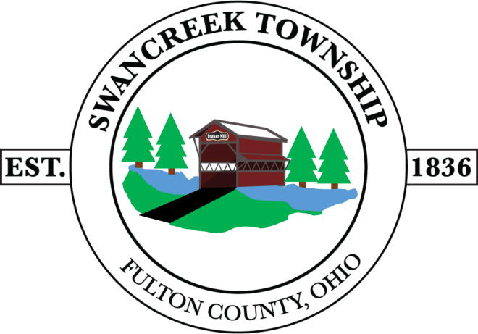
Website: www.swancreektwp.org
5565 County Road D,
Delta, Ohio
43515

Phone: 419-822-4371
Fax: SAME
BOARD OF TRUSTEES

RICK KAZMIERCZAK 419-708-6290
TRAVIS WEIGEL 419-270-2847
GENE WISON 419-344-0333

SWANCREEK TOWNSHIP BOARD OF TRUSTEES
2021 REGULAR MEETING DATES
Meetings are held on the 1st and 3rd Mondays of every month.
Regular BOT Meetings begin at 7pm.
Monday | January 4, 2021 5pm Organizational Mtg & Regular Mtg at 7pm |  | January 18, 2021
Monday | February 1, 2021 |  | February 15, 2021
Monday | March 1, 2021 |  | March 15, 2021
Monday | April 5, 2021 |  | April 19, 2021
Monday | May 3, 2021 |  | May 17, 2021
Monday | June 7, 2021 |  | June 21, 2021
Monday | July 12, 2021 |  | NO MTG
Monday | August 2, 2021 |  | August 16, 2021
Monday | NO MTG |  | September 13, 2021
Monday | October 4, 2021 |  | October 18, 2021
Monday | November 1, 2021 |  | November 15, 2021
Monday | December 6, 2021 |  | December 20, 2021
We will only have 1 meeting in the month of July & September

